**Unit V**

**Orthogonal Frequency Division Multiplexing (OFDM): Multicarrier modulation – OFDM transmitter and receiver – Cyclic Prefix in OFDM – Impact of Cyclic prefix on data rate. MIMO-OFDM. SC-FDMA transmitter and receiver.**

**Orthogonal Frequency-Division Multiplexing**

7.1 Introduction

Orthogonal Frequency-Division Multiplexing (OFDM) forms the basis for 4G, i.e., Fourth Generation wireless communication systems, such as Long-Term Evolution (LTE) and WiMAX (Worldwide Interoperability for Microwave Access).

OFDM is a key broadband wireless technology that supports data rates over 100 Mbps. The wireless local area (LAN) standards such as 802.11 a/g/n are based on OFDM. behind

**7.2 Motivation and Multicarrier**

**For a single-carrier communication system**

Consider a bandwidth B = 2W available for communication,

where W is the one-sided bandwidth or the maximum frequency.

**For a single carrier communication system**, the symbol time T is

T = 1 /B--------(1)

symbols can be transmitted at intervals of 1/ B seconds each

**Therefore, the symbol rate is**

Rate = 1/ 1/B = B -------------(2)

**It is called a single-carrier communication system.**

In such a system, a single carrier is used for the entire baseband bandwidth of B.

Therefore, the symbols are transmitted as symbol X(0) from 0 ≤ t < T,

symbol X(1) from T ≤ t < 2T, and so on,

i.e., one symbol transmitted every T = 1 /B seconds.

**Multi-carrier Concept**

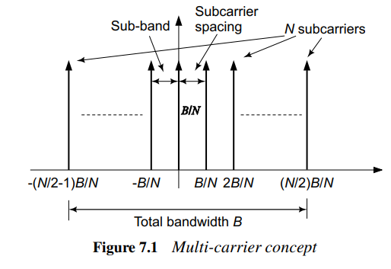

The total bandwidth B is divided into N sub-bands of bandwidth B/N each as shown in Figure 7.1. A subcarrier can now represent each subcarrier. Therefore, the subcarriers are placed at . . . , − B/N, ), 0, B/N, . . ., as shown in the figure.

For instance, consider the bandwidth B = 256 kHz with N = 64 subcarriers.

The bandwidth per sub-band equals 256 /64 = 4 kHz, is the frequency spacing between the subcarriers.

**Implement a multi-carrier transmission system as follows**.

Consider the ith subcarrier at the frequency

fi = iB/N ; with – (N/2 – 1)≤ i ≤ N/2 .

Let Xi denote the data transmitted on the ith subcarrier.

Signal si(t) corresponding to the ith subcarrier is given as



where fi is the ith subcarrier centre frequency and **ej2πfit**is the ith subcarrier.

The above equation shows the **data modulation process** over the ith subcarrier. The N different data symbols Xi are modulated over the N different subcarriers with centre frequencies fi. Hence, there are a total of N data streams.

**7.2.1 Multicarrier Transmission**

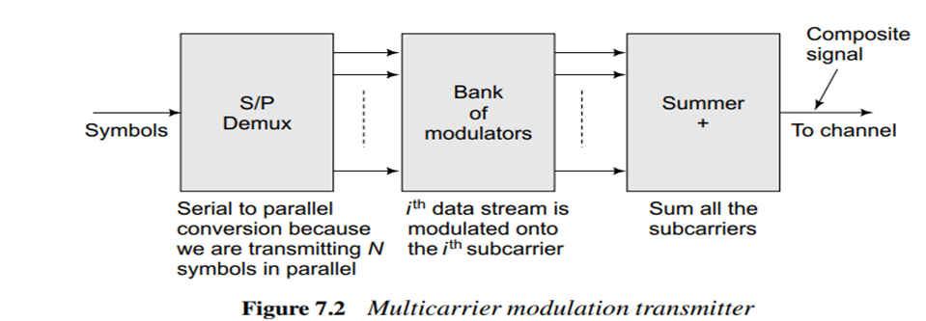

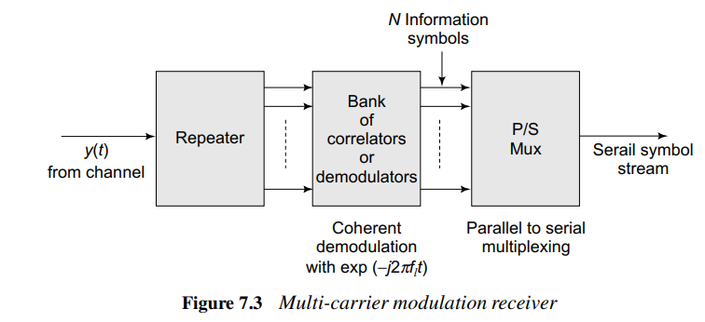

Consider the different modulated signals si (t) corresponding to the N different subcarriers. These signals are then superposed at the transmitter to form the composite signal s (t) given as

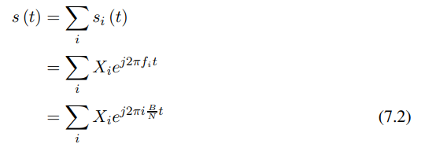

This composite signal s (t) is then transmitted over the wireless channels. Thus, N different data streams are transmitted over N subcarriers in parallel in this multicarrier system.

At the receivers, the individual data streams have then to be isolated from the composite signal s (t)

**The signal y (t) received**



The fundamental frequency **f0 = (B)N**.

All the frequencies i B/N are multiples of the fundamental frequency f0 = 1/T0 = B/N. Therefore, to extract Xl, which is the Fourier coefficient corresponding to the frequency fl = lf0,

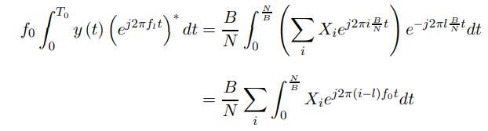

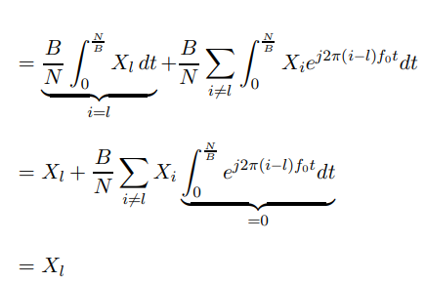

f 𝑙: The frequency of the 𝑙-th subcarrier.

𝑙:The subcarrier index, where 𝑙 ranges from 0 to 𝑁−1

B:The total bandwidth of the system.

N:The total number of subcarriers.



In the above expression, integrating a sinusoid of frequency (i − 𝑙) f0 which is a multiple of the fundamental frequency f0 over the period T0. Therefore, there are an integer number of cycles of the sinusoid of frequency (i −𝑙) f0, this integral is 0. It implies that the different sinusoids ej2πif0t and ej2πlf0t are orthogonal. Property of orthogonality which helps extract the different streams Xi modulated over the different subcarriers.

**This property of orthogonality**

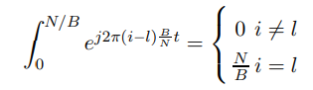

This property ensures that only the 𝑙-th subcarrier is isolated during demodulation. The process of multiplying the received signal y(t)with (ej2πfl​t )* (the conjugate of the carrier) and then integrating over the symbol period N/B is called **coherent demodulation**. It extracts the symbol sl(t) transmitted on the 𝑙-th subcarrier.

Thus, X𝑙, the data modulated on the different subcarriers, can be recovered by coherently demodulating with each of the subcarriers corresponding to 𝑙 = − (N/ 2 – 1) , . . . , N /2 . The above scheme of transmission is based on multiple orthogonal subcarriers and the associated data recovery at the receiver is termed **MultiCarrier Modulation (MCM).**

MCM transmits N symbols using N subcarriers in a time period of N/ B .

The symbol rate is, N/N/B = B.

Thus, the overall symbol rate in single carrier vs multicarrier systems is unchanged.

The symbol rate in both these systems is exactly identical, i.e., B. The single-carrier system transmits each symbol in time 1 B, while the MCM system transmits N symbols in parallel in time N/ B.

**Input Data Stream**

* **Purpose:** A high-rate input data stream is received for transmission.
* **Action:** This data stream is split into multiple lower-rate parallel data streams using **serial-to-parallel conversion**.
* Serial to parallel conversion because we are transmitting symbols in parallel N

**Bank of Modulators:** In a multicarrier system, the bank of modulators is a component that creates multiple subcarrier signals for data transmission. Each subcarrier carries a portion of the data and is modulated independently**. i.e** ith data stream is modulated on to the subcarrier benefit of this MCM system is that through parallel transmission using multiple narrowband subcarriers, it eliminates the Inter-Symbol interference (ISI), thus avoiding distortion of the received symbols.

**OFDM transmitter with IFFT and receiver with FFT**

Consider the MCM transmit signal s (t), it is band-limited to the bandwidth B (total bandwidth).

Therefore, the Nyquist sampling rate is B

sampling time is Ts = 1/B

Consider now the composite MCM signal given in Eq. (7.2).

The uth sample **at time instant uTs = u /B**

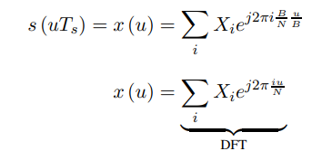

The above expression sample x (u) is the Inverse Discrete Fourier Transform (IDFT) coefficient of the information symbols X (0), X (1), . . . , X (N − 1) at the uth time point.

Thus, the Inverse Fast Fourier Transform (IFFT) can be used to generate the sample MCM signal This way of generating the composite transmit signal through IDFT reduces the complexity of implementing an OFDM system since it eliminates the need for the bank of modulators and demodulators

This technique, where the MCM signal is generated by employing the IFFT operation is termed **Orthogonal Frequency Division Multiplexing, or OFDM.**

At the receiver, to recover the information symbols, one can correspondingly employ an FFT operation., yet there is ISI

Schematic figures of the OFDM transmitter and receiver with the IFFT and FFT blocks are

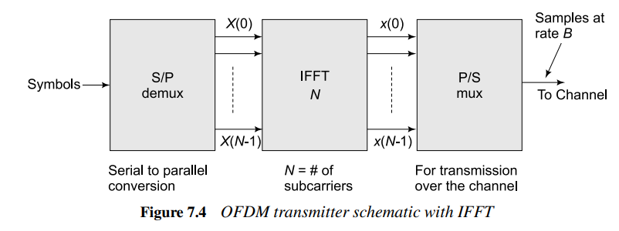

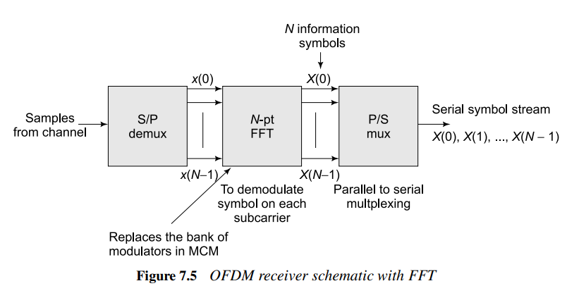

**7.2.2**

**Cyclic Prefix in OFDM**

The concept of cyclic prefix is an important component of an OFDM system.

* Consider a frequency-selective channel modelled with channel taps **:h (0), h (1), . . . , h (L − 1). L🡺 No. of taps**

The received symbol y at a given time instant n can be expressed as

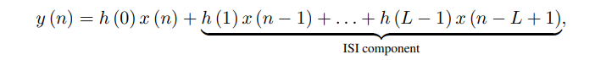

**Where L is the No. of Taps i.e multipath components**

The received symbol y (n) at the time instant n experiences inter-symbol interference from the previous L − 1 transmitted symbols.

* Consider two OFDM symbols as follows.

Let x (0), x (1), . . . , x (N − 1)these are transmitted at rate B corresponds to IFFT samples of the modulated symbols X (0), X (1), . . . , X (N − 1),

denote the IFFT samples of the previous modulated symbol block

The samples corresponding to these two blocks of OFDM symbols are transmitted sequentially

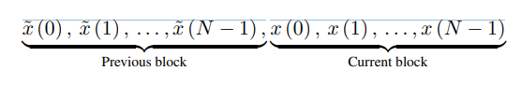

* 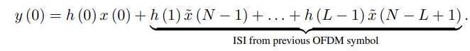Consider the received symbol y (0) corresponding to the transmission of x (0).

T**he term is the 1st sample**

Above equation that the received symbol y (0) experiences inter-symbol interference from

x˜ (N − 1), x˜ (N − 2), . . . , x˜ (N − (L − 1)). Thus, there is inter-OFDM symbol interference in this new OFDM system.

Similarly, the received symbol y (1) It is expressed as



It experiences inter-OFDM symbol interference from the previous OFDM block symbols

x˜ (N − 1), x˜ (N − 2), . . . , x˜ (N − L + 2).

* Now increase OFDM symbol size to N/B; which is larger than the delay spread. This leads to neglect of Intersymbol interference. In the previous method, the transmission time was 1/B. This is shown in Figure 7.6

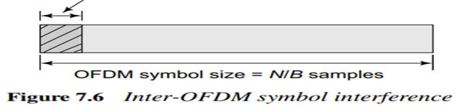Initial samples, of the subject to inter-OFDM symbol interference

* Consider a modified transmission scheme as follows.

We pad the last Lc symbols to each transmitted OFDM sample stream to make the transmitted stream as follows. 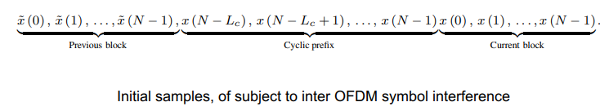

Prefixing the transmitted sample block x (0), x (1), . . . , x (N − 1) of the current block with the Lc samples x (N − Lc), x (N − Lc + 1), . . . , x (N − 1). This prefix is cyclic in nature, since the same samples from the end of the block are being cycled towards the beginning. **Therefore, this is known as the cyclic prefix and** is an important aspect of OFDM systems.

* Consider now the received symbol corresponding to x (0). This is given as

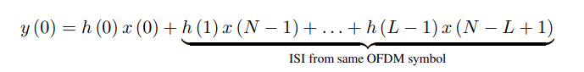

y(1)= h(0)x(1)+ h(1)x(0)+------------------+h(L-1)x(N-L+2)

- - -

- - - -

- - - -

y(N-1)= h(0)x(N-1)+ h(1)x(N-2)+------------------+h(L-1)x(N-L)

There is no ISI from previous samples of OFDM

The output y (n) is a circular convolution between the channel filter h (n) and the input x (n)

**[y(0) y(1) --------- y(N-1)] = [h(0) h(1)…….. h(L-1)] ∗ [x(0) x(1) ………x(N-1)]**

Therefore y=h ∗ x

This is possible because of addition of cyclic prefix

Therefore, taking the DFT of y (n) at the output, we have

Y(k) = H(k) X(k); 0 ≤ k ≤ N – 1

Where Y(k) 🡺 is the output at the Kth subcarrier.

The above equation is **for the flat fading channel**.

where **Y (k),** 0 ≤ k ≤ N − 1, denotes the N-point DFT of y(n).

**X (k)** denotes the N-point DFT of x (n).

**H(k) denotes the equivalent flat-fading channel coefficient.** This holds true for each subcarrier k, i.e., for 0 ≤ k ≤ N − 1.

**Thus, the frequency-selective fading channel is converted into a group of narrowband flat-fading channels**, one channel across each subcarrier

Also, the modified transmitter and receiver schematics with the blocks corresponding to the cyclic prefix are given in Figures 7.8 and 7.9 respectively.

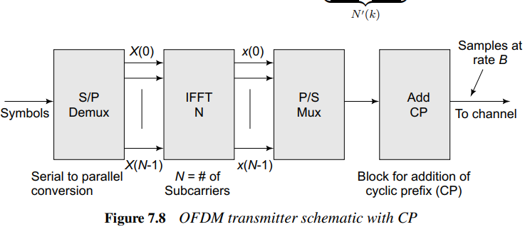

The set of parallel flat-fading channels can be summarized by the expressions

**Y (0) = H (0) X (0)**

**Y (1) = H (1) X (1)**

**. .**

**. .**

**. .**

**Y (N − 1) = H (n − 1) X (N − 1)**

This conversion of the frequency-selective wideband channel into N narrowband flat-fading

channels is shown schematically in Figure 7.7.

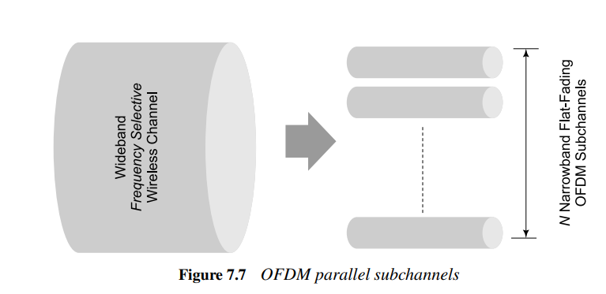

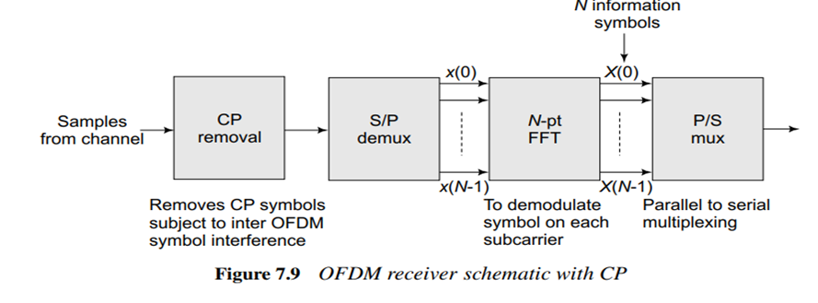

**Considering the noise at the receiver**, the received symbol Y (k) can be expressed as

Y (k) = H (k) X (k) + N (k)

where N (k) denotes the noise across the kth subcarrier.

**[Note: Zero force detector: E**liminate inter-symbol interference (ISI) caused by overlapping signals in MIMO or multi-user systems. The ZF detector applies a linear filter to the received signal, effectively "forcing" the interference components to zero**.]**

A simple detection scheme for X (k) is to use the zero-forcing detector for the subcarrier as

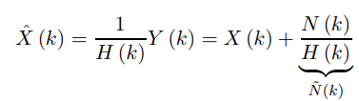

Considering BPSK is used for transmission, the coherent or matched filter detector can be obtained by multiplying with H∗ (k), i.e., the complex conjugate of H (k) as

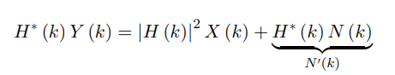**Matched filter detector**

**[Note: Minimum Mean-Squared Error(MMSE): refers to a statistical approach used in estimation, prediction, and signal processing to minimize the average of the squared differences between estimated values and the actual values]**

**The MMSE detector as**

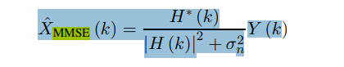

**:** The MMSE estimate of the transmitted signal X(k) for the k-th subcarrier or channel.

**H(k):** The channel frequency response or transfer function for the k-th subcarrier or channel. It describes how the channel modifies the transmitted signal.

**H ∗ (k):** The complex conjugate of 𝐻(𝑘) Used to reverse the phase shift introduced by the channel.

**|H(k)|^2:** The power gain of the channel at the (k-th subcarrier or channel, computed as 𝐻(𝑘).𝐻∗(𝑘)

**𝜎𝑛 2 :**The noise variance or power of the additive white Gaussian noise (AWGN) in the system. This **term accounts for the noise affecting the received signal.**

**7.2.3 Impact of Cyclic Prefix on Data Rate**

**Consider the transmitted Sequence of OFDM samples**

**x(0) x(1)……..x(N-1)**

**with the cyclic prefix, as given below**



The minimum required length of the cyclic prefix is L – 1.

**Cyclic Prefix > delay spread of the channel**

The samples in the tail, i.e., x (N − Lc), x (N − Lc + 1), . . . , x (N − 1) are simply repeated in the beginning, they do not constitute any additional information.

**Hence, the effect of the addition of a long CP is a loss in the throughput of the system**

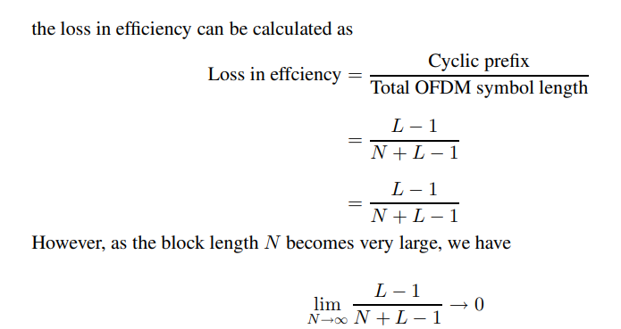**There is a trade-off between CP and Throughput of the system**

* The loss in throughput approaches 0 as the number of subcarriers N increases,
* **Fixed length of the delay spread L** the number of **subcarriers N increases**, the symbol time **N /B increases** as shown in Figure 7.10.
* Hence increasing N🡺 increases **OFDM symbol time**,
* Thus **restricting the ISI** to a **small fraction** of the OFDM symbol block, i.e., the fraction **L/ N is progressively** smaller.
* The block length **N increases** and the **decoding delay at the receiver also increases** as one has to wait for the arrival of the entire block of N samples before it can be demodulated.
* Hence, there **is a trade-off for increasing N** vs **decoding delay**.

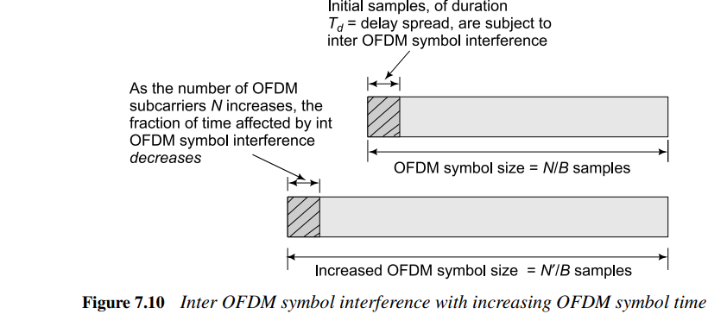

Therefore, we need

Lc × Ts ≥ Td;

where Lc🡺 No. symbols in the of cyclic prefix

Ts🡺 sample time;

Ts= 1/B; **B** is each subcarrier bandwidth of the system

Td 🡺 is the delay spread

` Td = 1 /2Bc,

where Bc is the coherence bandwidth of the system.

The above condition implies

Lc ≥ Td/Ts ≥ ½ B/Bc

N >> Lc

**for efficiency** in terms of the effective data rate, we have

N >> Lc ≥ **½ B/Bc**

B is the bandwidth of each subcarrier

Bc is the coherence bandwidth

N is the No. of sub-carrier

N >> B/Bc

Bc >> B/N

Subcarrier bandwidth is less than coherence bandwidth hence each subcarrier experiences flat fading (B< Bc).

Thus, an appropriately designed OFDM system converts a frequency-selective fading channel into a set of parallel narrowband flat-fading channels across the subcarriers

**7.5 MIMO-OFDM**

* MIMO-OFDM combines the multiple input and multiple output (MIMO) wireless technology with OFDM.
* It increases the rate in broadband multi-antenna wireless systems.
* Similar to OFDM, MIMO-OFDM converts a frequency-selective MIMO channel into multiple parallel flat-fading MIMO channels.
* Hence, MIMO-OFDM significantly simplifies baseband receive processing by eliminating the need for a complex MIMO equalizer.

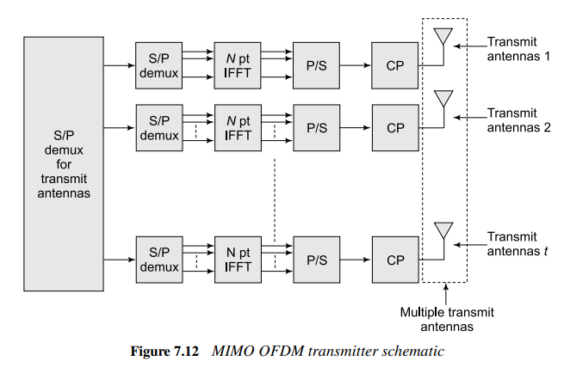**Figure 7.12 MIMO OFDM transmitter schematic**

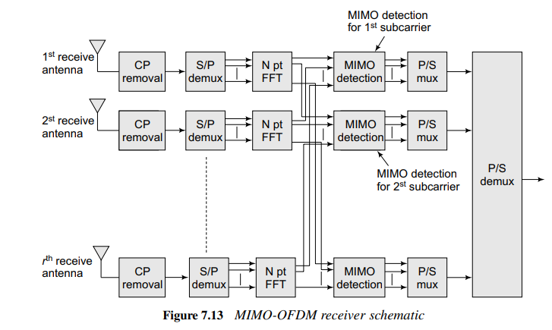

**The frequency-selective SISO channel is modelled as an FIR channel filter, with**

**Output y (n) at time instant n given as**

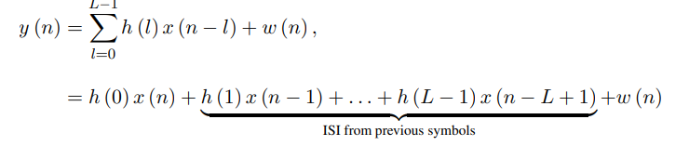

where **w (n)** denotes the noise.

**Hence, a MIMO frequency-selective channel can be modeled as a MIMO FIR filter, which can be described as**

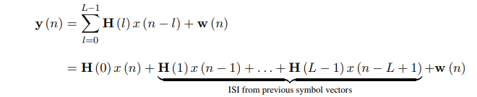

* Therefore, the symbol vector y (n) at the time instant n is affected by inter-symbol vector interference from x (n − 1), x (n − 2), . . . , x (n − L + 1). This is an **L-tap frequency-selective MIMO channel**.
* In a MIMO-OFDM system, the IFFT operation is required at each transmit antenna.
* The schematic figures showing the processing at the transmitter and receiver of the MIMO-OFDM system are shown in **figures 7.12 and 7.13 respectively**.
* **Hence, employing MIMO-OFDM, the MIMO frequency-selective channel can be converted into a set of parallel flat-fading MIMO channels.**

At the output of each subcarrier, it is

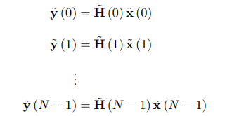

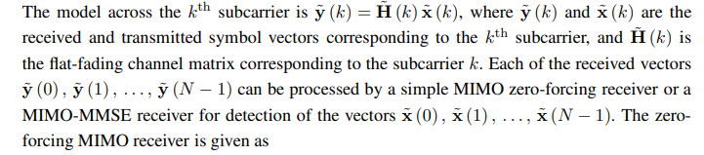The model across kth subcarrier is

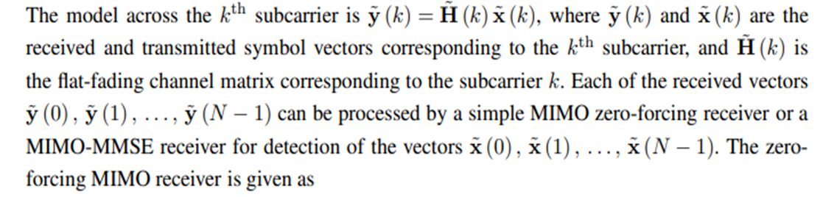are the received rx1 vector symbol and transmiteed tx1 vector symbolcorressponding to the kth subcarrier

is the flat lading channel matrix corresponding to the kth subcarrier.

These symbols vector is loaded onto the antenna over the kth subcarrier.

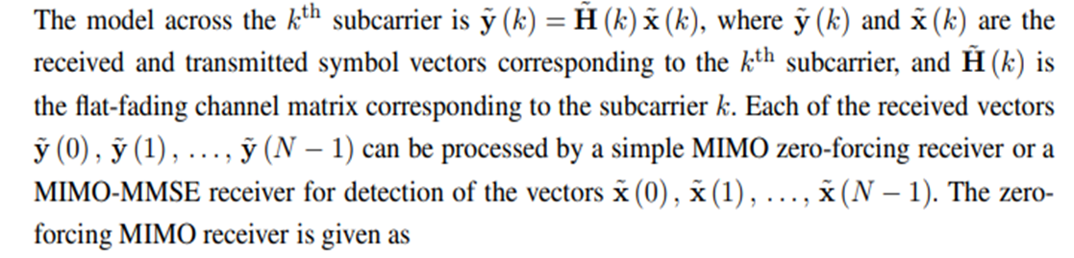Each of the received vectors are

is processored by the MIMO Zero-force receiver or MMSE receiver for the detection of the Vector

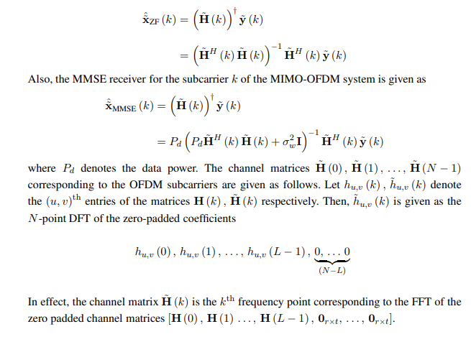**The Zero-forceing MIMO receiver**

Where Pd is the data power

We can detect the data from the flat fading channel matrix across the ‘N’ OFDM subcarrier



The vector of the (u,v)th elements of the matrix

**7.8 SC-FDMA Single-Carrier Frequency Division for Multiple Access**

It is used to reduce the peak-to-average power ratio in an OFDM system.

Note:

FFT:Input: Time-domain signal (e.g., audio waveform).Output: Frequency-domain signal (magnitude and phase of frequency components).

IFFT:Input: Frequency-domain signal.Output: Time-domain signal.

S/P DEMUX: It takes a single input data stream and distributes it across multiple output lines

P/S MUX: data from multiple parallel input lines and sends it sequentially over a single serial output line.

P/S Demux: Converts parallel data to serial for transmission.

**N-Point:**The FFT operates on N input data points, where N is typically a power of 2 (e.g., 8, 16, 32, etc.).

The FFT and IFFT ensure that the subcarriers remain orthogonal, which minimizes interference between them and maximizes spectral efficiency.

* Consider the following hypothetical modification of the OFDM transmitter, shown in Figure 7.17,
* By inserting an N-point FFT block before the N-point IFFT block.
* The FFT and IFFT ensure that the subcarriers remain orthogonal, which minimizes interference between them and maximizes spectral efficiency.hence the FFT and the IFFT cancel the effect of each other and the net output is the exact input symbol stream, i.e., **corresponding to a single-carrier system.**
* This reduces the PAPR(Peak-to-Average Power Ratio), the PAPR(Peak-to-Average Power Ratio) of a single-carrier system is 0 dB.
* Instead of using an N-point FFT, one can use an M-point FFT, where M < N, to reduce the PAPR, while still retaining the properties of the OFDM system.
* This proposed SC-FDMA schematic is shown in Figure 7.18.
* This is the central principle of SC-FDMA.
* Using 𝑁 -point FFT for the initial transformation at the transmitter would unnecessarily process 𝑁 values, including zeros for unallocated subcarriers.
* This would increase computational complexity, waste power, processing resources, and Complicated subcarrier allocation and mapping.
* By using M-point FFT for the input data and N-point IFFT/FFT for the overall system, SC-FDMA ensures efficient and practical implementation.

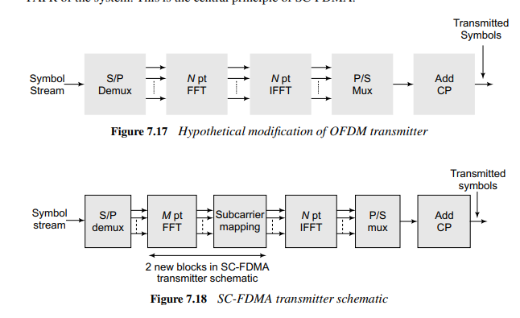

**Subcarrier Mapping:** Subcarrier mapping, in which the M samples at the output of the M-point FFT are mapped to the N subcarriers, is a key operation in SC-FDMA, a block representation of which **can be seen in the SC-FDMA transmitter schematic in Figure 7.18. The various possible**

**SC-FDMA subcarrier mappings:**

**The DFT** output is mapped to subcarriers in either a localized or distributed manner.

**IFFT:** An IFFT converts the signal back to the time domain, creating a composite time-domain signal.

**Cyclic Prefix Addition:**

A cyclic prefix is appended to mitigate inter-symbol interference (ISI) caused by multipath propagation. The time-domain signal is transmitted over the channel.

**7.8.1 SC-FDMA Receiver**

The SC-FDMA receiver schematic is shown in Figure 7.19.

The SC-FDMA receiver consists of two new blocks compared to the OFDM receiver. The purpose of these additional blocks can be described as follows.

After the N-point FFT operation at the receiver, the signals are equalized across all the subcarriers, to remove the effect of the fading-channel coefficient across the subcarriers.

Following the above operation, they are demapped from the subcarriers, which are N in number, to the original FFT block size of M. Finally, the M-point FFT is performed on these samples to generate the symbol stream

